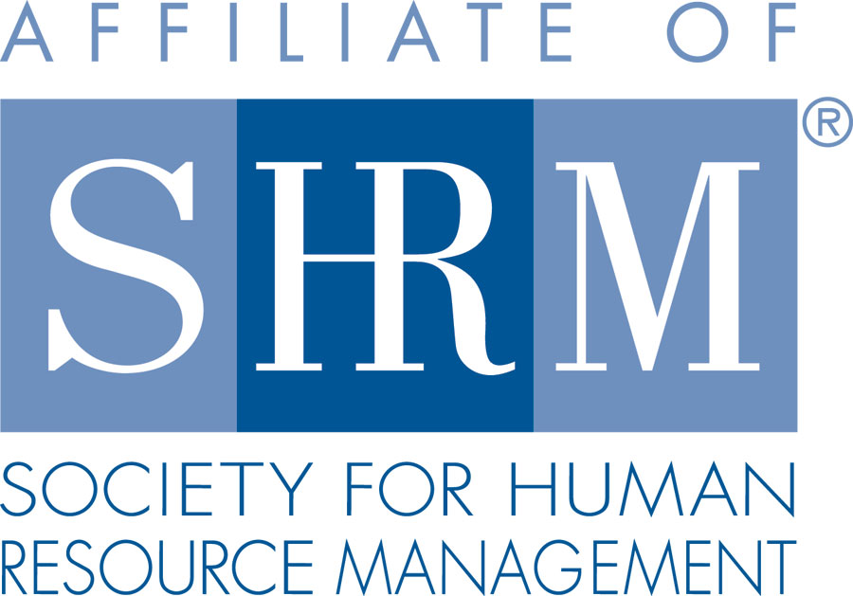
HR Management Assoc. of North Central PA
Minutes for October 20, 2016
Topic: Emergency Preparedness
Presenter/ Facilitator: Tracey Zents, Director of Jefferson County Department of Emergency Services

Membership was welcomed by President, Carol Wells, at 8:01 am.
25 were present.

Items of Business discussed:
- Planning is key to be effective. The plan needs to be tested, revised, and updated on a regular basis.
- Preparedness – Response – Recovery – Mitigation
- What do we prepare for? Natural disasters, manmade disasters, acts of aggression, and health related emergencies.
- How do we prepare for an emergency when we don’t know our surrounding? Take a few minutes when you arrive at your destination for emergency exits, shelters, etc.
- Where should you prepare? Home, work, vacation
- Response – When it’s time to put your plan into action, it will be chaotic.
- Recovery – Every situation will be different, but planning for recovery after a situation is vital. Go-kits are a good idea.
- Go-kits are essential items for you. Food, medication, water.
- For a detailed list see www.ready.gov
- Mitigation – Are there steps that I could take to prevent this from happening again? How can I lessen the impact of a disaster? Are there mitigation measures I can do at home as well at work?
- Fire – When dealing with fires, life safety is always the first consideration. Fires can happen at any place, any time. Preparing for a fire can protect you, your co-workers and visitors.
- In the event of a fire, evacuate building, activate the nearest fire alarm, and immediately call 911.
- Report the following: exact location of the fire, building, floor number & room number, your name/call back number, and describe the fire.
- If the fire is small and you have been trained on the use of a fire extinguisher, attempt to extinguish the fire. Make sure someone has called 911.
- Even if you are not trained in CPR or first aid, knowing what to do in a Medical Emergency will assist in saving lives.
- If an ambulance is needed, answer all the questions that are asked. Location, nature, name/ phone number you are calling from, age of the patient if known. At this time, the ambulance will be dispatched, HOWEVER DO NOT HANG UP!!!!!!
- A second dispatcher will ask more questions and will give you more instructions on how to care for the patient until the ambulance arrives.
- Have co-workers move any bystanders away from the patient and have someone go to the front door to meet EMS and direct them in.
- CPR training would be a good thing for your business to have.
- Severe weather – every year, thousands are impacted by severe weather threats such as tornados and thunderstorms. Everyone is at risk and should be prepared to take action when severe weather strikes.
- Planning for severe storms will save lives and prevent injuries.
- In the event of a tornado, get to the lowest level of the building and stay in an interior hallway away from windows.
- If appropriate to evacuate after the event is over, use extreme caution.
- Learn more about the weather visit www.weather.gov
- Active shooter/violent person – An active shooter is described as an individual actively engaged in killing or shooting someone in a particular area.
- Immediate deployment of law enforcement is required to stop the shooting and mitigate harm.
- Everyone must be prepared both mentally and physically to deal with an active shooter situation.
- Three decisions to make: evacuate, hide out, or take action against the shooter.
- Always keep hands up if you are evacuating so they don’t think you are the shooter.
- If you are hiding out be out of the shooter’s view, lock doors, turn lights off, silence cell phone, don’t move, and remain quiet.
- If you cannot speak call 911 and leave the line open. You can also text to 911.
- Suspicious activity – if you see something, say something!

Upcoming Events shared:
- There will be a Drug Free Workplace Training on Tuesday November 1, 2016. 1:00 pm-4:00 pm or 5:00 pm-8:00 pm. It will be held at White Wave Foods in Dubois, PA. The class is free. You can register at www.drugfreeworkplacetraining.eventbrite.com or call the Clearfield Jefferson Drug and Alcohol Commission at (814) 371-9002.

Next Meeting:
The next meeting will be Thursday November 17, 2016.

